- Wireless Standard & Configuration

Q1. Set up a basic wireless network using a home Wi-Fi router and connect your laptop or phone to it, then note down the SSID and the default channel used by the router?

Answer
- In Packet Tracer, I used a WRT300N wireless router with Laptop0 and Smartphone0 to represent a small home WLAN.
- I used HOME-WIFI as the wireless network name (SSID).
- The router initially used channel 1 in the 2.4 GHz band (2.412 GHz).
- Both wireless clients were associated with the configured SSID.
- With DHCP enabled, the client addressing plan was as follows:
  - Laptop0: 199.168.0.101 (example address)
  - Smartphone0: 199.168.0.100 (example address)
- Result: The network demonstrates how a wireless router connects multiple clients through one SSID.
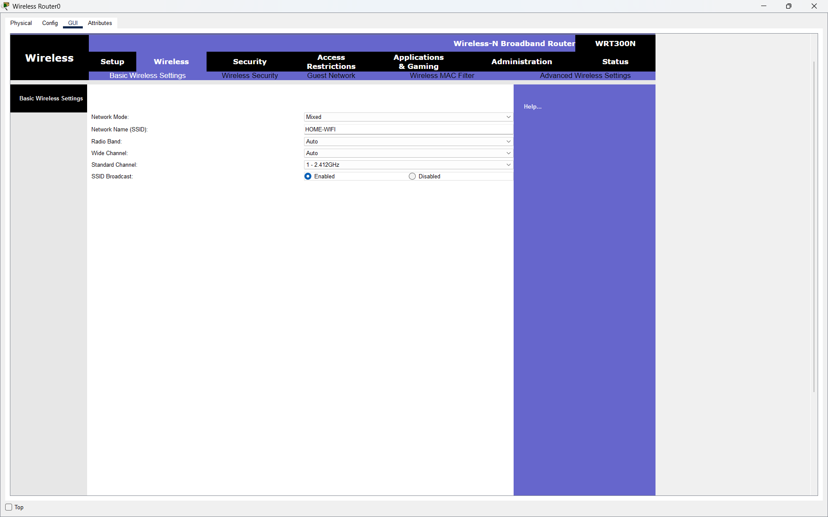
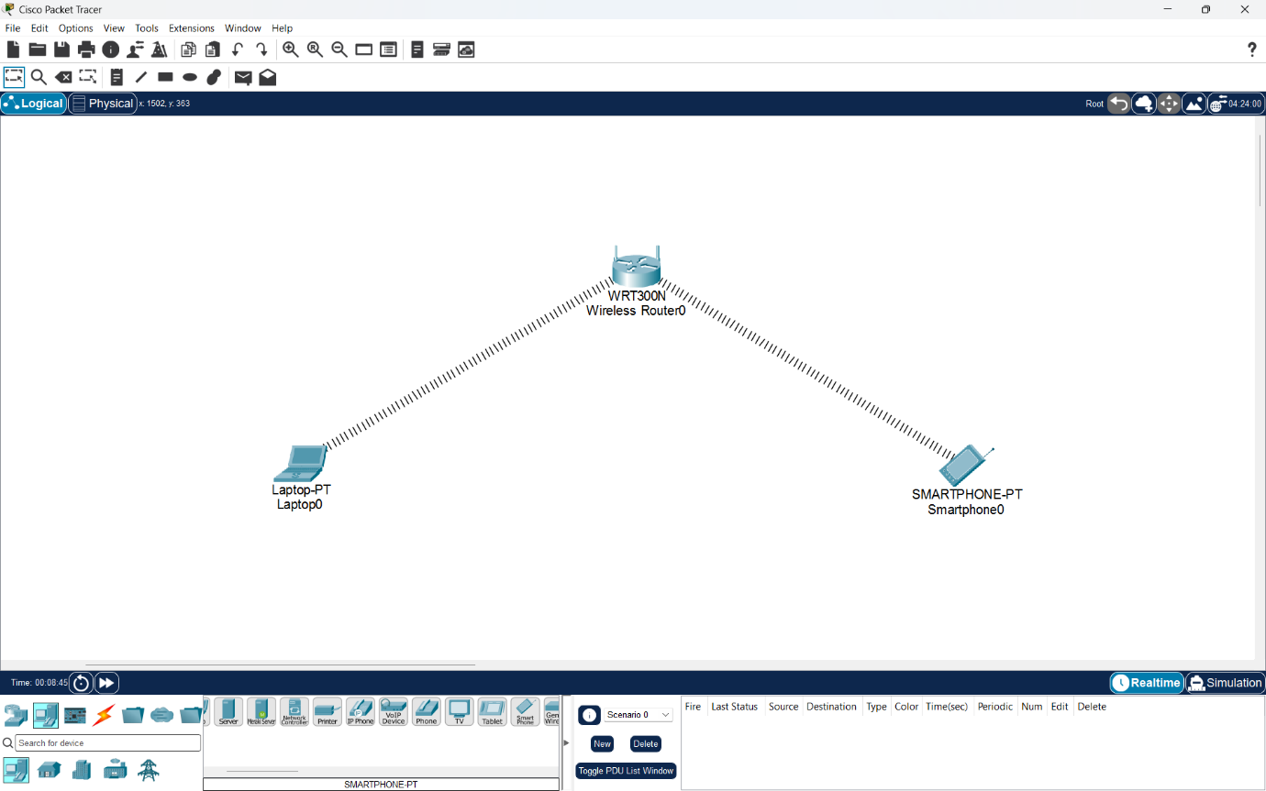

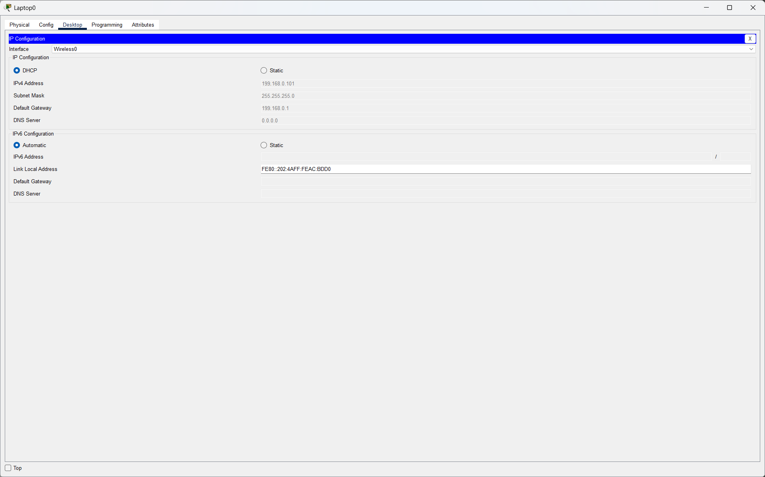
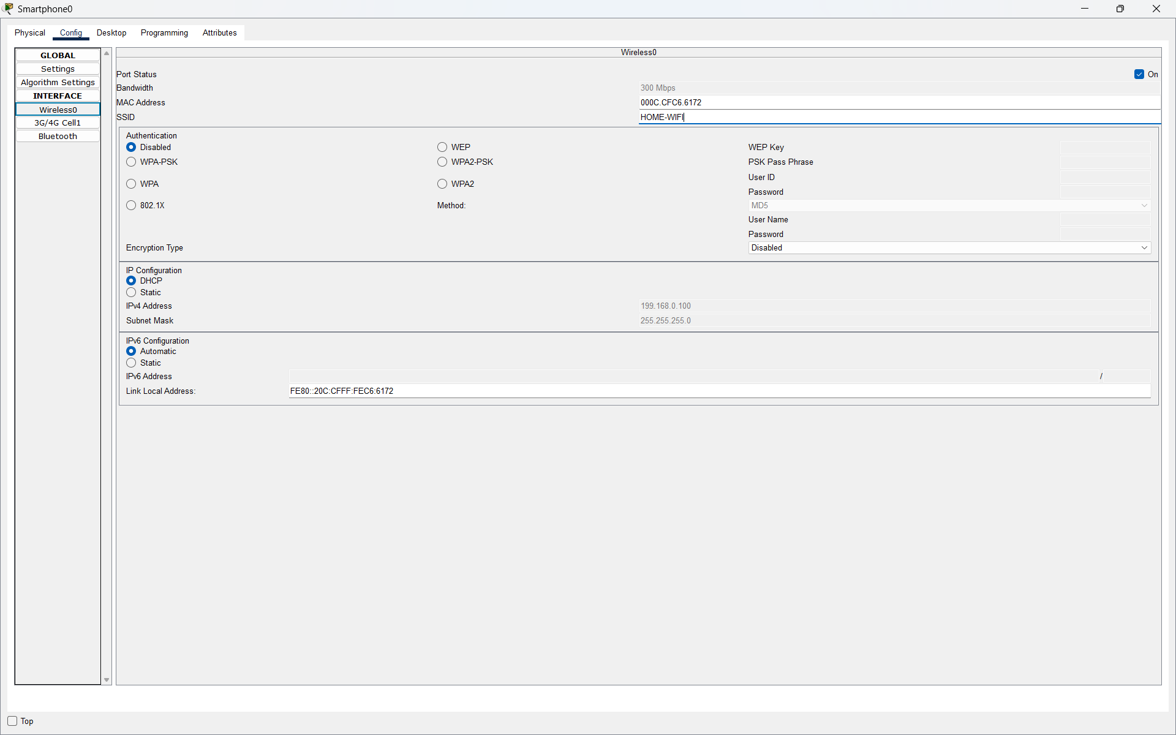

Q2. Change your Wi-Fi router's channel setting from 'Auto' to a manually selected channel (such as 1, 6, or 11), then use a Wi-Fi analyzer app on your phone to check if your new channel has less interference from nearby networks.<br><br><em><strong>Hint:</strong> Look for overlapping channels and pick one with the least overlap.</em>?

Answer
- I opened the Wi-Fi settings of the WRT300N from its configuration interface.
- I changed the operating channel from 1 (2.412 GHz) to 6 (2.437 GHz).
- I reviewed Laptop0 association after choosing the new channel.
- Channel selection is intended to reduce interference from overlapping nearby 2.4 GHz networks.
- Result: Channel 6 was selected; Packet Tracer alone does not measure real-world neighboring-network interference.
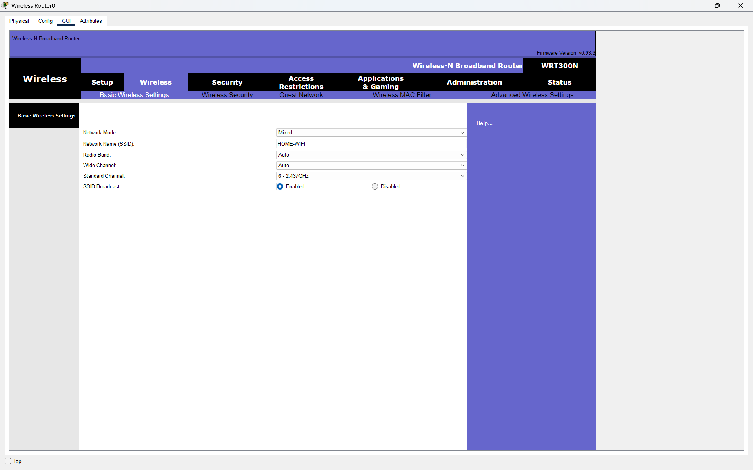
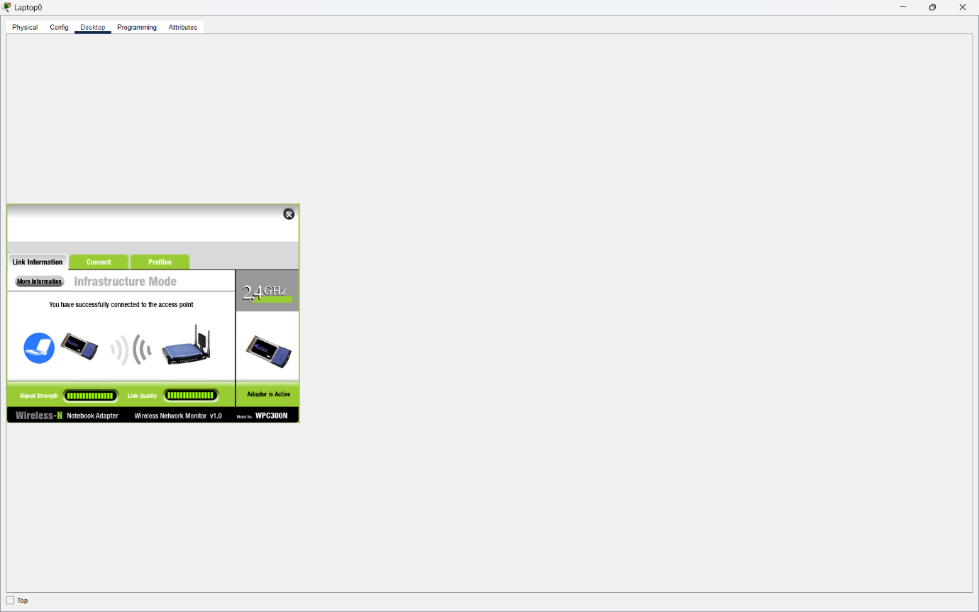

Q3. Enable WPA2 or WPA3 security on your wireless router, set a strong password, and attempt to connect a device using the new credentials to verify the security setting is active?

Answer
- I chose WPA2-Personal for wireless authentication on the WRT300N router.
- I selected AES for encryption and specified a Wi-Fi passphrase.
- The wireless-client settings were matched to the router’s WPA2-PSK configuration.
- I checked whether Laptop0 could associate using the selected security credentials.
- Result: WPA2-Personal with AES provides a password-protected wireless connection when configured consistently.
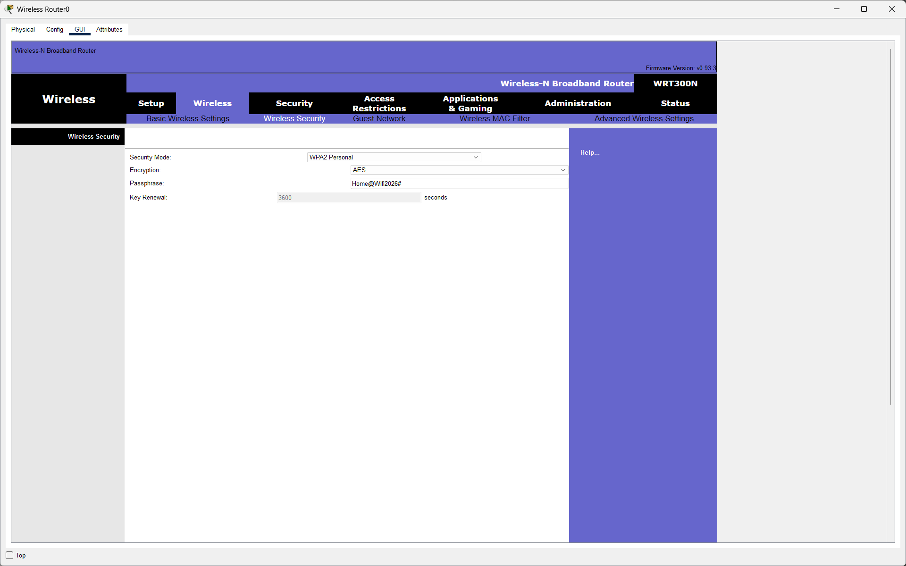
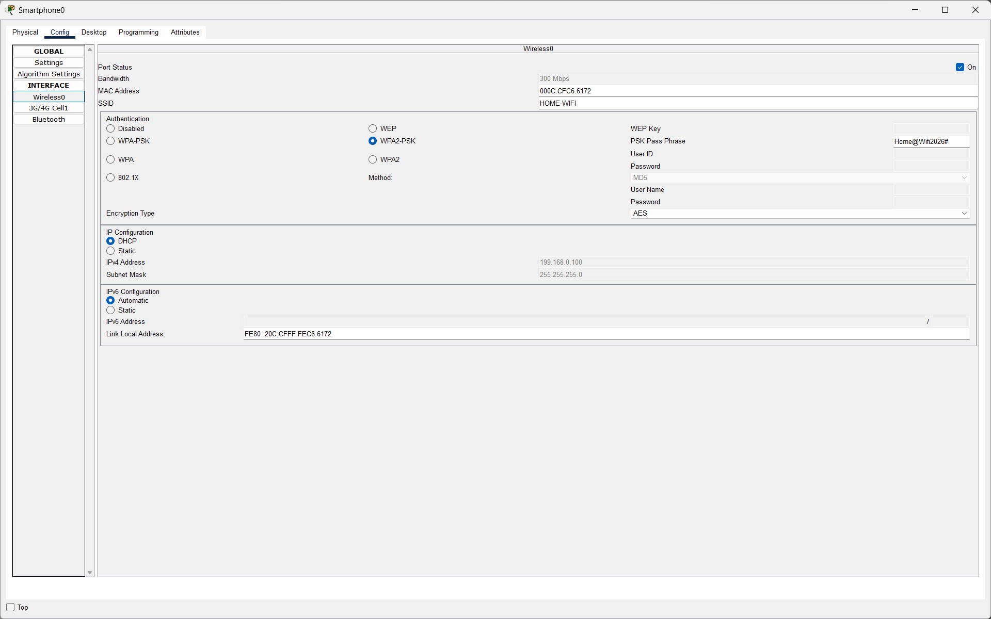
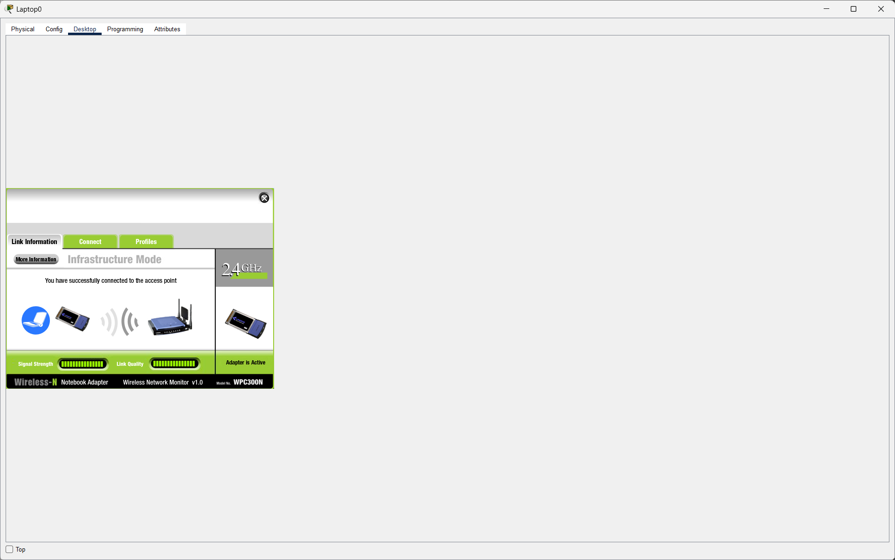

Q4. Configure MAC filtering on your Wi-Fi router by adding your device's MAC address to the allowed list, then try connecting with another device not on the list and observe the result.<br><br><em><strong>Hint:</strong> You can find your device's MAC address in the network settings.</em>?

Answer
- For access control, I selected the MAC-address filtering feature on the wireless router.
- I used the allow-list option, which accepts only devices whose hardware addresses appear in the configured list.
- For an alternative configuration example, the allowed Laptop0 MAC address is 02:4A:7C:21:B3:60 (example only; not the measured device MAC).
- Smartphone0 is intentionally left out of that example allow-list.
- Under a correctly enforced allow-list, Smartphone0 should be denied association until its own MAC address is added.
- Result: MAC filtering can limit which device addresses are admitted, although it should not replace WPA2 security.
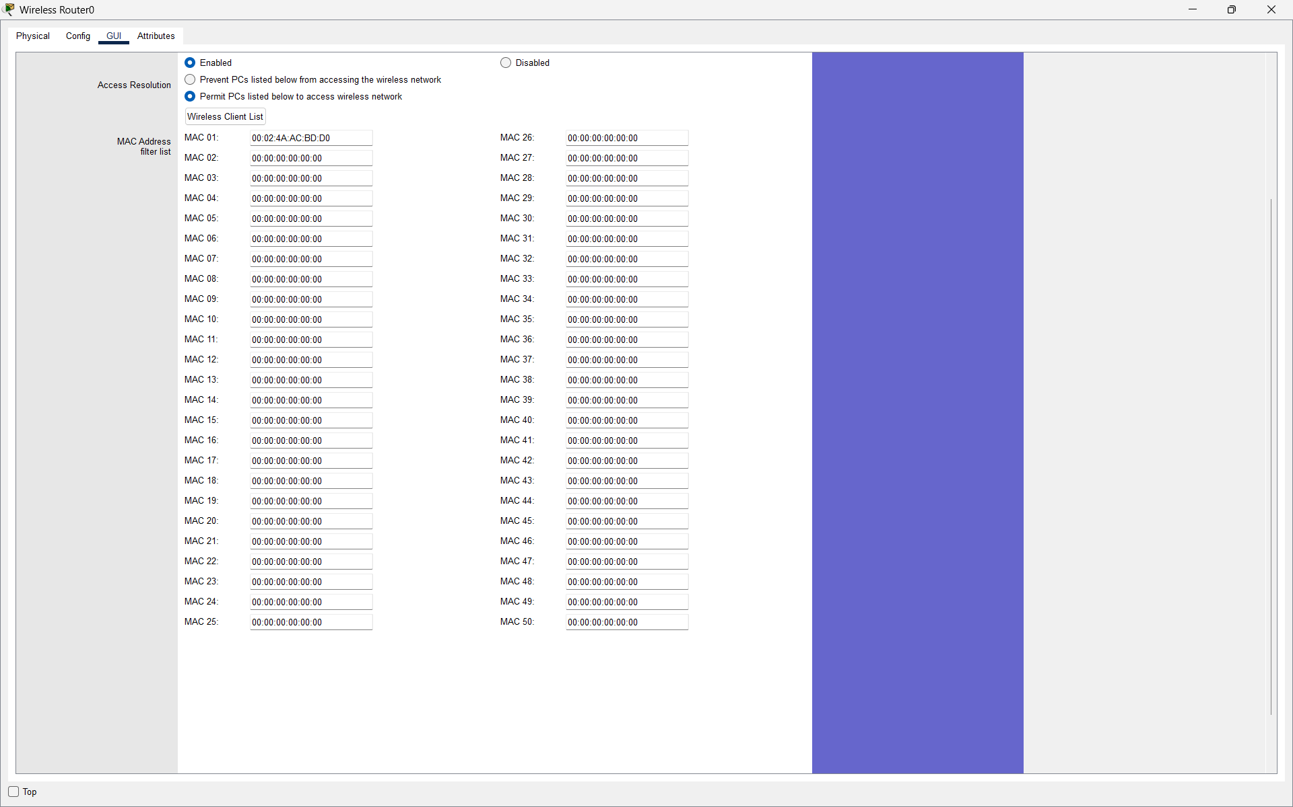
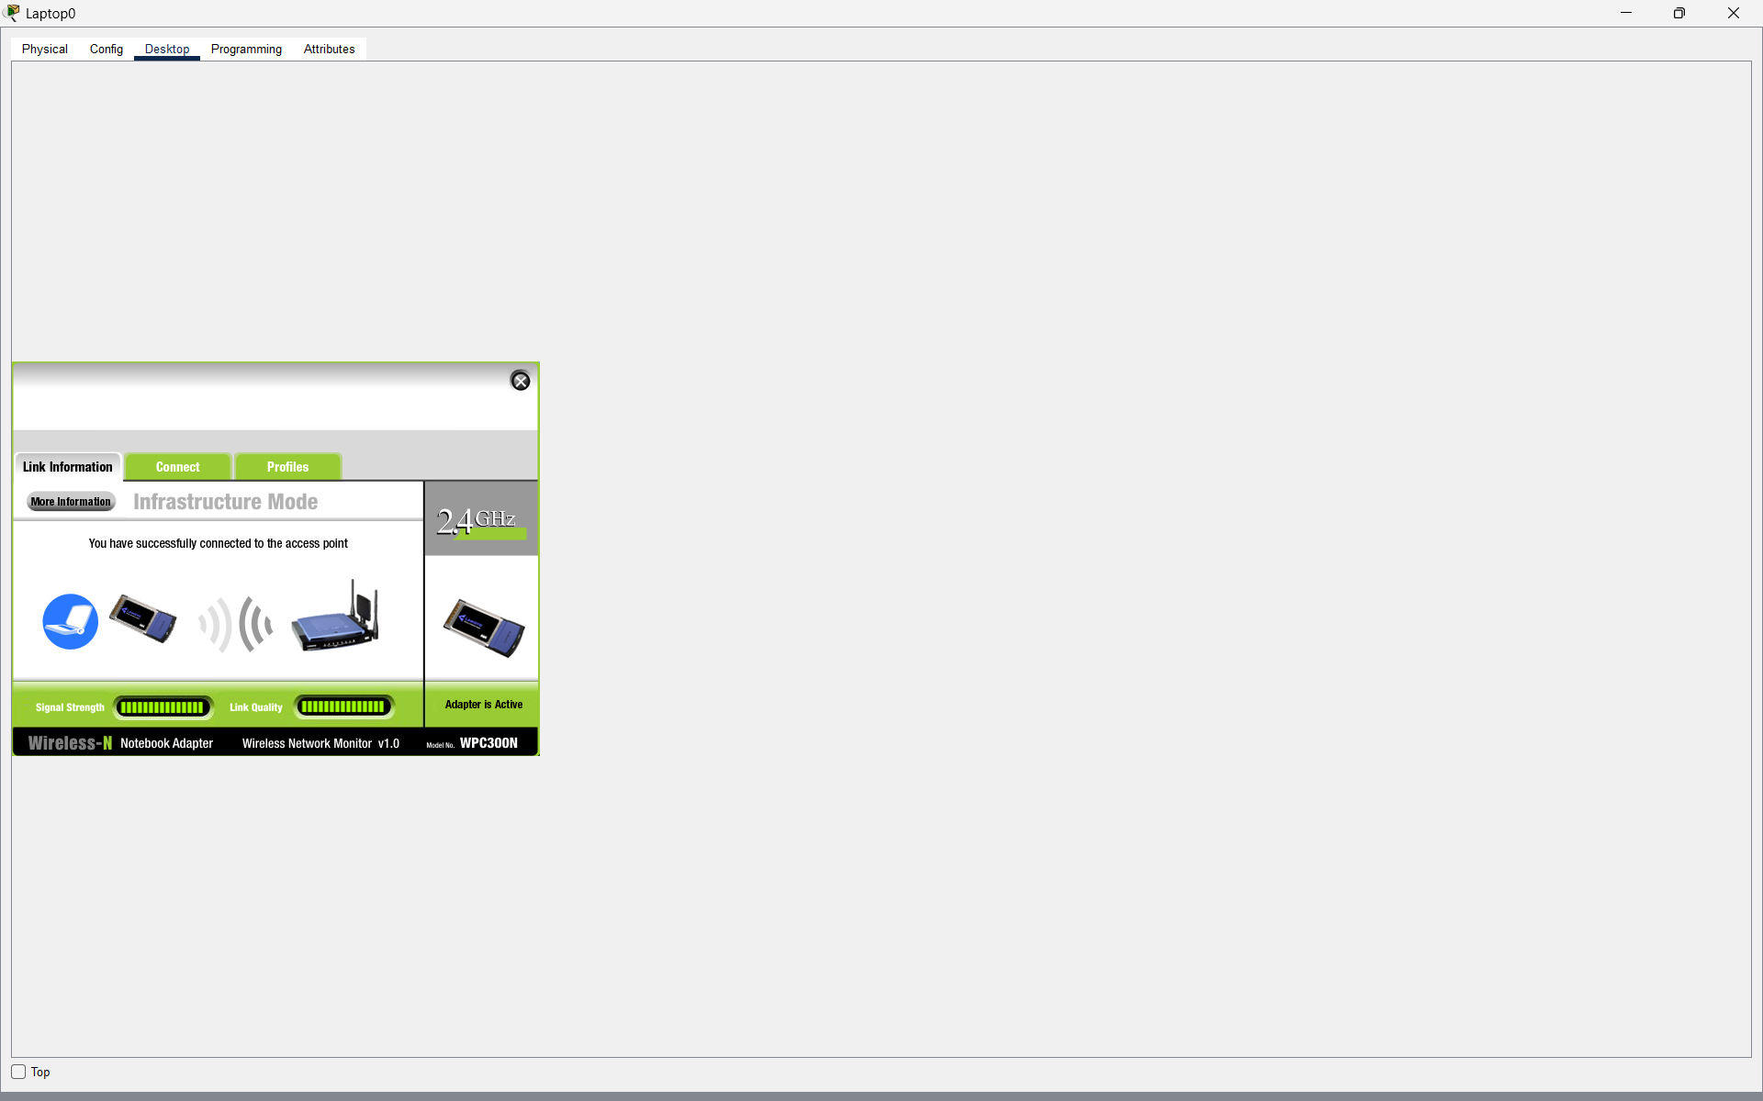
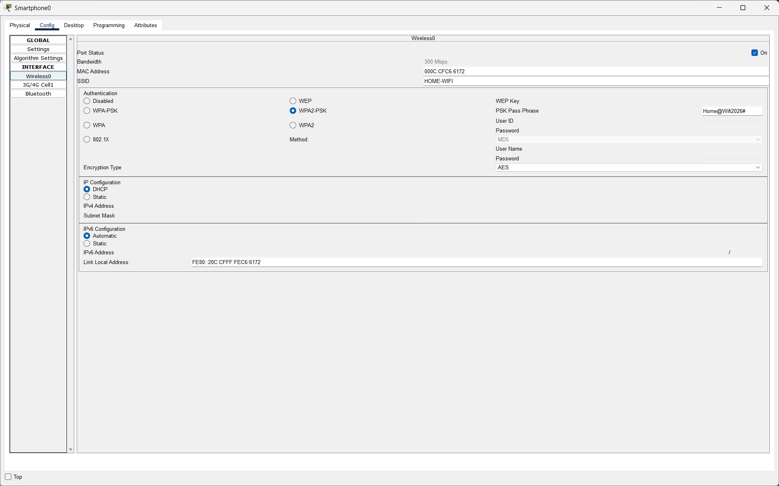

Q5. Create an Access Control List (ACL) on your router to block access to a specific website (for example, www.youtube.com) from your Wi-Fi network, and test if the block is working by trying to access the site from a connected device?

Answer
- I went to the WRT300N Access Restrictions panel to define a browsing policy.
- I named the example restriction policy Block-Youtube and enabled it.
- I selected Laptop0 at 199.168.0.101 as the client to which the policy would apply (example address).
- I entered www.youtube.com as the website to restrict.www.youtube.com
- I checked the policy using the laptop browser as far as Packet Tracer permits.
- Result: The policy illustrates website restrictions, but real YouTube reachability cannot be verified through Packet Tracer’s simulated internet.
